Comp 3350: Computer Organization & Assembly Language

HW # 10: Theme: Strings and Arrays
- [Case Table] Write a program that asks the user to enter a score and prints the letter grade based on the score (see table below). The program should display your numerical grade as well as the letter grade. You should reference the section of the text that discusses Table Driven Selection. Use the following data as a guide for letter grade and score range association:

TITLE LETTER GRADE LOOKUP
INCLUDE IRVINE32.INC
.DATA
INPUTMSG BYTE "ENTER YOUR SCORE(0 - 100): ",0
OUTPUT BYTE " IS THE LETTER GRADE:",0
OUTPUT1 BYTE "A",0
OUTPUT2 BYTE "B",0
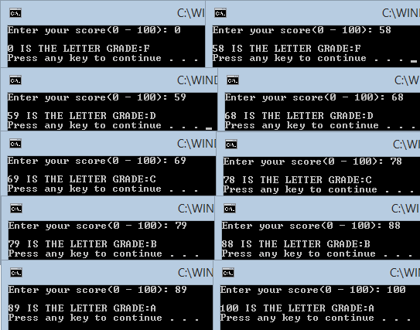
OUTPUT3 BYTE "C",0
OUTPUT4 BYTE "D",0
OUTPUT5 BYTE "F",0
.CODE
MAIN PROC
MOV EDX, OFFSET INPUTMSG
CALL WRITESTRING
CALL READDEC
MOV EDX, OFFSET OUTPUT1
CMP EAX, 89
JAE LBX
MOV EDX, OFFSET OUTPUT2
CMP EAX, 79
JAE LBX
MOV EDX, OFFSET OUTPUT3
CMP EAX, 69
JAE LBX
MOV EDX, OFFSET OUTPUT4
CMP EAX, 59
JAE LBX
MOV EDX, OFFSET OUTPUT5
CMP EAX, 0
JAE LBX
LBX:
PUSH EDX
CALL CRLF
CALL WRITEDEC
MOV EDX, OFFSET OUTPUT
CALL WRITESTRING
POP EDX
CALL WRITESTRING
CALL CRLF
EXIT
MAIN ENDP
END MAIN

- [Strings] Write an x86 procedure that implements the Unix strcpy procedure.
Use a main program to call your procedure with your name as a string, a one character string and a zero character string. Provide screen shots of the runs along with your program.
TITLE STRCPY IMPLEMENTATION
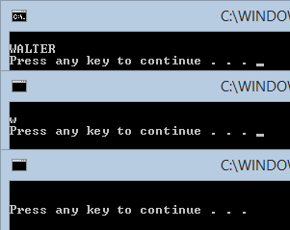
INCLUDE IRVINE32.INC
.DATA
SOURCE BYTE "WALTER",0
TARGET BYTE 7 DUP(?)
.CODE
MAIN PROC
PUSH OFFSET TARGET
PUSH OFFSET SOURCE
CALL STRCPY
CALL CRLF
MOV EDX, OFFSET TARGET
CALL WRITESTRING
CALL CRLF
EXIT
MAIN ENDP
STRCPY PROC
PUSH EBP
MOV EBP, ESP
PUSHAD
CLD
MOV ESI, [EBP+8]
MOV EDI, [EBP+12]
MOV ECX, LENGTHOF SOURCE
REP MOVSB
POPAD
POP EBP
RET 8
STRCPY ENDP
END MAIN

- [General Programming] Write a program that converts the temperature F in Farenheit to C in Celsius using C = (F-32)*5/9. For ease of programming you can display the result in fractions, i.e. C = 20 1/9 (no need to use floats, just display the quotient, the slash character and the digit 9). Show the runs for freezing, boiling point, room temperature and human body temperature. Provide screen shots of the runs along with your program.

TITLE TEMP CONVERSION
INCLUDE IRVINE32.INC
.DATA
INPUTMSG BYTE "ENTER THE TEMP TO CONVERT TO CELSIUS: ",0
ANSOUTPUT BYTE "C = ",0
SLANT BYTE "/9",0
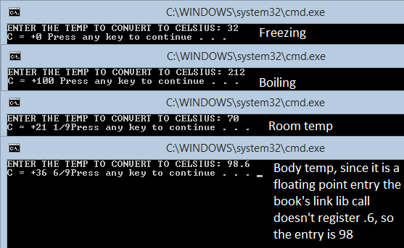
SPACE BYTE " ",0
.CODE
MAIN PROC
MOV EDX, OFFSET INPUTMSG
CALL WRITESTRING
CALL READINT
PUSH EAX
CALL TEMPCONV
EXIT
MAIN ENDP

TEMPCONV PROC
PUSH EBP
MOV EBP, ESP
MOV EAX, [EBP+8]
SUB EAX, 32
IMUL EAX, 5
MOV EBX, +9
CDQ
IDIV EBX
PUSH EDX
MOV EDX, OFFSET ANSOUTPUT
CALL WRITESTRING
POP EDX
CALL WRITEINT
PUSH EDX
MOV EDX, OFFSET SPACE
CALL WRITESTRING
POP EDX
PUSH EAX
MOV EAX, EDX
TEST EAX,EAX
JNS LBNOTNEG
LBNEG:
NEG EAX
LBNOTNEG:
CMP EAX, 0
JE LBFIX
CALL WRITEDEC
POP EAX
PUSH EDX
MOV EDX, OFFSET SLANT
CALL WRITESTRING
POP EDX
JMP LBEXT
LBFIX:
POP EAX
LBEXT:
POP EBP
RET 4
TEMPCONV ENDP
END MAIN

